升温时的△V—T拟合直线：
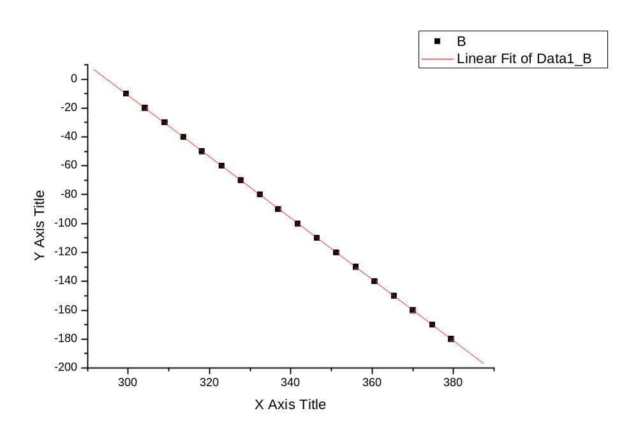
Linear Regression for Data1_B:
Y = A + B * X

Parameter Value Error
------------------------------------------------------------
A 626.3819 0.63327
B -2.12525 0.00186
------------------------------------------------------------

R SD N P
------------------------------------------------------------
-0.99999 0.19273 18 <0.0001
------------------------------------------------------------

降温时的△V—T拟合直线：
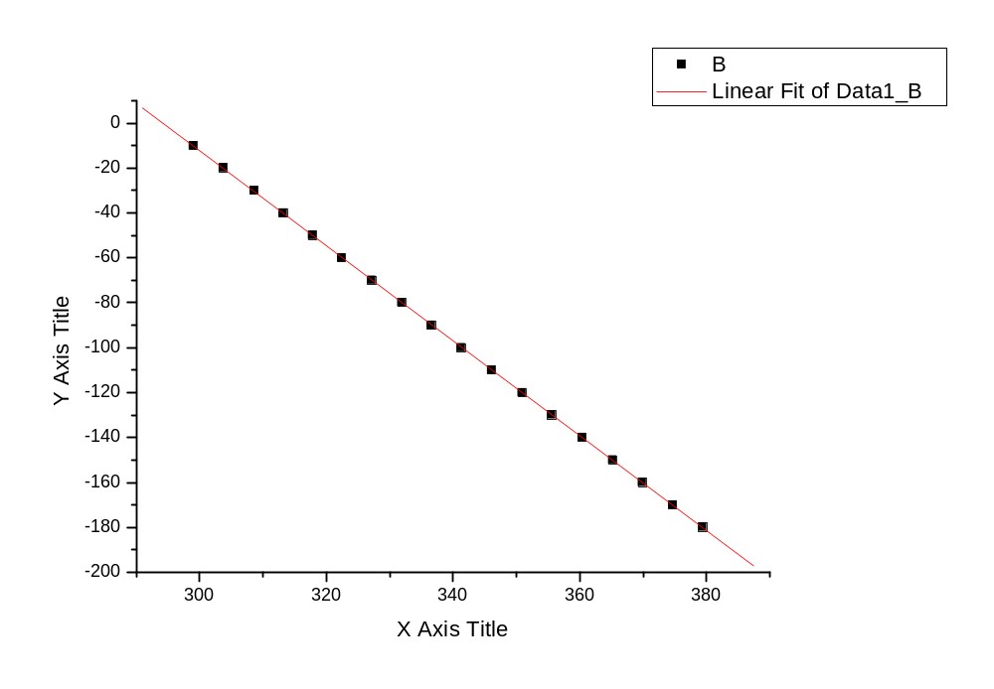
Linear Regression for Data1_B:
Y = A + B * X

Parameter Value Error
------------------------------------------------------------
A 622.07792 0.80975
B -2.11462 0.00238
------------------------------------------------------------

R SD N P
------------------------------------------------------------
-0.99999 0.24791 18 <0.0001
------------------------------------------------------------

